Stiffness in Roller Bearings

Rotodynamic responses are heavily dependant on the properties of bearings. Rolling element bearing forces vary non-linearly with the deflection of the contacting elements [1]. Lundberg and Palmgren [2] published load-stress relationships for rolling element bearings Average stiffness values cannot be used across a wide range of th

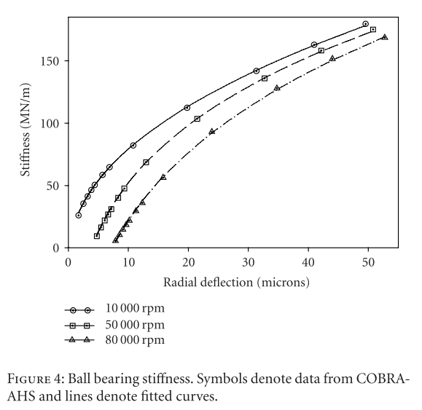

Figure 1 - Deflection-Stiffness relationship

[3]

[1] D. P. Fleming and J. V. Poplawski, “Unbalance Response Prediction for Rotors on Ball Bearings Using Speed- and Load-Dependent Nonlinear Bearing Stiffness,” *Int. J. Rotating Mach.*, vol. 2005, no. 1, pp. 53–59, 2005, doi: 10.1155/ijrm.2005.53.

[2] G. Lundberg and A. Palmgren, “Dynamic capacity of rolling bearings,” *Acta Polytech. Mech. Eng. Ser.*, vol. 1, no. 3, 1947.

[3] H. Questa, M. Mohammadpour, S. Theodossiades, C. P. Garner, S. R. Bewsher, and G. Offner, “Tribo-dynamic analysis of high-speed roller bearings for electrified vehicle powertrains,” *Tribol. Int.*, vol. 154, 2021, doi: 10.1016/j.triboint.2020.106675.